Continuous Internal Assessment III

Chapter 15

*Connecting LANs - Yiyasu Paudel (1740243)*

*2 Markers:*

1. **What is one of the major functions of a bridge?**

A bridge has filtering capability. It can check the destination address of a frame and decide if the frame should be forwarded or dropped. If the frame is to be forwarded, the decision must specify the port. A bridge has a table that maps addresses to ports.

1. **Why is source routing bridges used?**

Along with spanning trees, source routingbridges are used to prevent loops in a system with redundant bridges. The duties of the systems are performed by the source station and the destination station. In source routing, the frame contains not only the source and destination addresses, but also the addresses of all bridges to be visited.

1. **What is the function of the repeater?**

A repeater connects segments of a LAN. Unlike bridge, it does not have filtering capacity. Moreover, it regenerated signal. When thesignal it receives is corrupted, it creates a copy at the original signal (bit for bit).

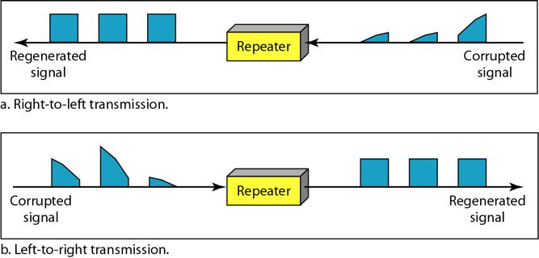

*5 Markers:*

1. **What is the difference between 2 layer switch and 3 layer switch?**

|  |  |
| --- | --- |
| **2 Layer Switch** | **3 Layer Switch** |
| It operates within layer 2 of the OSI model. | It operates within layer 3 of the OSI model. |
| It is a bridge with many ports and a design that allows faster performance. | It is a router, but faster and more sophisticated. |
| It uses MAC addresses to facilitate communication within devices from the same network. | It uses IP addresses to link different subnets together using dynamic routing protocols. |
| It reduces traffic on the local network. | It is used to implement VLAN. |
| Switching is faster as it only looks at layer 2 portion of data packets. | It is slower than a 2 layer switch. |
| It is used to communicate within a network. | It can communicate inside as well as outside network. |
| It has a single broadcast domain. | It has multiple broadcast domain. |

1. **What is the difference between Transparent Bridge and Source Routing Bridge?**

|  |  |
| --- | --- |
| Transparent Bridge | Source Routing Bridge |
| Transparent Bridge is connectionless. | Source Routing Bridge is connection oriented. |
| It does not support multipath routing. | It can make use of multiple path to same destination. |
| Mechanism bridges automatically develop a routing table. | Bridges do not maintain any routing information. |
| The path between two hosts may not be optimal. | The path is always optimal. |
| It can handle failure on its own. | The failure is handled by host. |
| It is transparent to the users | It is not visible to the hosts |

1. **Is it possible for a bridge to connect LANs using different protocols? If so, what are the issues that it may encounter?**

A bridge should be able to connect LANs using different protocols at the data link layer, such as an Ethernet LAN to a wireless LAN. However, it may encounter the following issues:

* **Frame format:** Each LAN type has its own frame format
* **Maximum data size:** Large data are fragmented into several frames and are reassembled at the destination. The main issue here is that no protocol at the data link layer allows the fragmentation and reassembly of frames. The bridge must discard any frames too large for its system.
* **Data rate:** Each LAN type has its own data rate and the buffering of the frame is done by the bridge to compensate for this difference.
* **Bit order:** Each LAN type has its own strategy in the sending of bits where some send the most significant bit in a byte first; others send the least significant bit first.
* **Security:** Wireless LANs implement security measures whereas Ethernet does not. Security measures involve encryption of messages. When the frame is received by bridge from Wireless LAN, it then decrypt the message before forwarding it to an Ethernet LAN.
* **Multimedia support:** Some LANs support multimedia and the quality of services needed for this type of communication.

*10 Markers:*

1. **Explain different categories of connecting devices based on the layer with a neat diagram.**

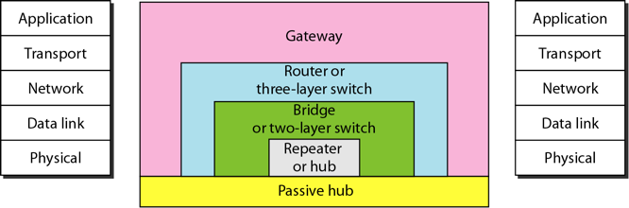

**Passive Hubs**

* A passive hub is just a connector that connects the wires coming from different branches.
* It is situated below the physical layer.

**Repeaters**

* A repeater is a device that operates only in the physical layer.
* A repeater receives a signal, regenerates the original bit pattern and then sends the refreshed signal.
* A repeater can extend the physical length of a LAN.
* Also, it does not actually connect two LANs; it connects two segments of the same LAN.
* A repeater forwards every frame; it has no filtering capability.

**Bridges or 2 layer switch**

* A bridge operates in both the physical and the data link layer.
* As a physical layer device, it regenerates the signal it receives.
* As a data link layer device, the bridge can check the physical (MAC) addresses (source and destination) contained in the frame.
* A two-layer switch is a bridge, a bridge with many ports and a design that allows better (faster) performance.

**Routers or 3 layer switch**

* A router is a three-layer device that routes packets based on their logical addresses (host-to-host addressing).
* A router normally connects LANs and WANs on the Internet and has a routing table that is used for making decisions about the route.
* A three-layer switch is a router, but faster and more sophisticated.

**Gateway**

* Gateway is a computer that operates in all five layers of the Internet or seven layers of OSI model.
* It takes an application message, reads it, and interprets it which means that it can be used as a connecting device between two internetworks that use different models.

1. **What is a looping problem? Explain briefly on the algorithm that IEEE specification requires to solve the looping problem.**

Redundant bridges means to have more than one bridge between a pair of LANs and are required in a system to make the system more reliable. If a bridge fails, another bridge takes over until the failed one is repaired or replaced. Redundancy can create loops in the system, which is very undesirable. This is known as a looping problem. Now, the concept of spanning trees is used as a solution to this problem which helps build a loop free topology.

Spanning tree is a graph in which there is no loop. In a bridged LAN, this means creating a topology in which each LAN can be reached from any other LAN through one path only. We cannot change the physical topology of the system because of physical connections between cables and bridges, but we can create a logical topology that overlays the physical one. To find the spanning tree, we need to assign a cost (metric) to each arc. It may be the path with minimum hops, the path with minimum delay, or the path with maximum bandwidth. The path is obtained in the following order:

* Every bridge has a unique built-in ID. Each bridge broadcasts this ID so that all bridges know which one has the smallest ID. The bridge with the smallest ID is selected as the rootbridge.
* The algorithm tries to find the shortest path (a path with the shortest cost) from the root bridge to every other bridge or LAN. The shortest path can be found by examining the total cost from the root bridge to the destination.
* The combination of the shortest paths creates the shortest tree.
* Based on the spanning tree, we mark the ports that are part of the spanning tree, the forwarding ports, which forward a frame that the bridge receives. We also mark those ports that are not part of the spanning tree, the blocking ports, which block the frames received by the bridge.

There will only be a single path created from a LAN to any other LAN in the spanning tree system and thus, there will be no loops.

Each bridge is equipped with a software package that carries out all processes mentioned above dynamically in the spanning tree. The bridges send special messages to one another, called bridge protocol data units (BPDUs), to update the spanning tree. The spanning tree is updated when there is a change in the system such as a failure of a bridge or an addition or deletion of bridges.

*Connecting LANs and Backbone Networks - Chaitanya Agarwal (1740204)*

*2 Markers:*

1. **What is the difference in functionality between a repeater and a bridge?**

A bridge has the capability to filter frames. It has the option to either forward or drop the frame based on the destination address. A repeater on the other hand just has the functionality to reproduce the signal sent to it.

1. **Define a Transparent Bridge. Is reconfiguration of the station necessary when a bridge is added or deleted?**

A transparent bridge can be defined as a bridge in which stations are completely unaware of its existence. No, reconfiguration is not necessary.

1. **List and briefly explain any 2 issues encountered when connecting different LAN’s with a bridge.**

* Frame format : Each LAN has its own type of file format
* Data rate : Each LAN has its own data rate. Bridge has to compensate for this difference.
* Multimedia support : Some LAN’s support multimedia and QoS. Others do not.

1. **Which device can be used to connect multiple networks using different network models and why?**

A gateway can be used to connect networks operating on different models as they usually operate in all 5 or 7 layers in the Internet/OSI model respectively.

1. **Define a Backbone network.**

A backbone network can be defined as a network that connects different networks, providing a medium to exchange information between different LAN’s or subnets.

1. **What are the 2 most common architectures(topology) for backbone networks?**

Bus topology for bus backbone and Star topology for star backbone

1. **Which type of backbone is commonly referred to as a collapsed backbone and why?**

Star backbone is commonly referred to as collapsed backbone as it consists of only a single switch.

*5 Markers:*

1. **List and explain the issues faced when connecting different LAN’s with a bridge.**

* Frame format : Each LAN has its own type of file format
* Data rate : Each LAN has its own data rate. Bridge has to compensate for this difference.
* Multimedia support : Some LAN’s support multimedia and QoS. Others do not.
* Maximum data size : If an incoming frame is too large, it needs to be broken into smaller fragments and reassembled. Currently no protocol supports such operations. Therefore the bridge must discard any frame that is too large.
* Bit Order : Each LAN has its own way of sending bits. Some send the most significant first, the other send them last.
* Security : Some LAN’s such as WLAN’s implement security features while others such as Ethernet do not. When a bridge receives a frame, it needs to decrypt it before forwarding it to an Ethernet LAN.

1. **Discuss the 2 most common types of Backbone networks. Explain their functionality in detail.**

The 2 most common types of Backbone networks are :

* Star Backbone
* Bus Backbone

Star Backbone(also referred to as a collapsed backbone) is a network that follows a star topology. In this configuration, there exists only one switch that connects the LAN’s. Star backbones are commonly used as a distribution backbone inside a building. If we consider a multi level building, one LAN is dedicated to each floor and each of these LAN’s are connected by a star backbone.

Bus Backbone is a type of backbone network that follows a bus topology. Bus backbones are normally used to connect different buildings in an organization. Each building can have its own LAN or another backbone(usually a star backbone). A bus backbone can then be used to connect these LAN’s.

*10 Markers:*

1. **Explain in detail, the 2 most common types of backbone networks with the help of diagrams.**

Bus Backbone is a type of backbone network that follows a bus topology. Bus backbones are normally used to connect different buildings in an organization. Each building can have its own LAN or another backbone(usually a star backbone). A bus backbone can then be used to connect these LAN’s.

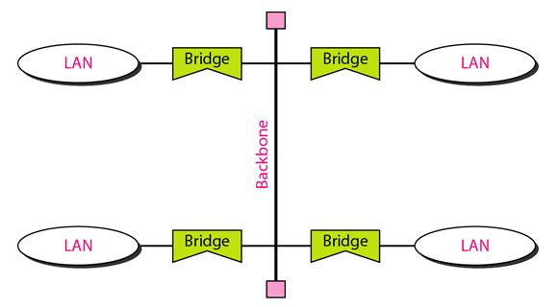

Star Backbone(also referred to as a collapsed backbone) is a network that follows a star topology. In this configuration, there exists only one switch that connects the LAN’s. Star backbones are commonly used as a distribution backbone inside a building. If we consider a multi level building, one LAN is dedicated to each floor and each of these LAN’s are connected by a star backbone.

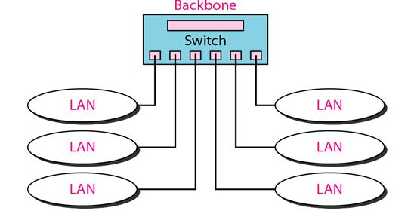

*Virtual LANs: Connecting Devices, Hubs, Repeaters, Bridges, Switches, Routers, Gateway. - Jeevan Koshy (1740256)*

*2 Markers:*

1. ***Wh*at are the 3 categories of connecting devices and what is its use?**

The connecting devices are used to connect hosts together to make a network or connects networks together to make an Internet. These connecting devices can operate in different layers of the internet model. The 3 different kinds of connecting devices are:

* Hubs ~ Operate in 1st layer of internet model
* Link - layer switches ~ Operate in 1st 2 layers
* Routers ~ Operate in 1st 3 layers

*5 Markers:*

1. **Define the following:**

* Hub
* Repeater
* Bridge
* Switch
* Router
* Gateway

Hub

A hub is a device that operates only in the physical layer.

A repeater is a multi - port device in star topology often called a hub.

Repeater

Receives a signal and regenerates the original bit pattern before it becomes too weak or corrupted.

Bridge

Operates in both physical and data link layers.

Is a 2 layer switch with many ports having a design that allows faster and better performance.

Can check the physical (MAC) addresses in the frame which it behaves as a data link layer device.

Regenerates the signal it receives.

Switch

A link layer switch (also known as switch) operates in both physical and data link layers.

Regenerates the signal it receives as a physical layer device.

Can check the MAC addresses that are contained in the frame.

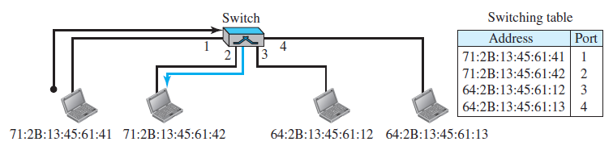

The above diagram is an example of a link layer switch.

Router

Operates in physical, data - link and network layers.

Regenerates the signal it receives as a physical layer device.

It checks the network layer addresses as a network layer device.

Is an internetworking device which connects independent networks to form an internetwork.

Changes the link layer address of a packet.

Has a physical and logical IP address for each of its interfaces.

Gateway

Operates in 5 layers of the internet or 7 layers the OSI model.

Takes an application message, reads and then interprets it.

Used as a connecting device between 2 internetworks that use different models

1. **Elaborate on the concept of transparent switch**

A transparent switch is a switch in which the stations are completely unaware of the switch’s existence. If a switch is added or deleted from the system, reconfiguration of the stations is unnecessary. According to the IEEE 802.1d specification, a system equipped with transparent switches must meet three criteria:

* Frames must be forwarded from one station to another.
* The forwarding table is automatically made by learning frame movements in the network.
* Loops in the system must be prevented.

1. **Mention the different advantages of switches**

Out of the many advantages that a switch has over a hub, let us look in detail 2 of them:

Collision Elimination: A link-layer switch eliminates the collision. This means increasing the average bandwidth available to a host in the network. In a switched LAN, there is no need for carrier sensing and collision detection; each host can transmit at any time.

Connecting Heterogeneous Devices: A link-layer switch can connect devices that use different protocols at the physical layer (data rates) and different transmission media. As long as the format of the frame at the data-link layer does not change, a switch can receive a frame from a device that uses twisted-pair cable and sends data at 10 Mbps and deliver the frame to another device that uses fiber-optic cable and can receive data at 100 Mbps.

1. **Discuss the Spanning Tree Algorithm**

To solve the looping problem, the IEEE specification requires that switches use the spanning tree algorithm to create a loopless topology. In graph theory, a spanning tree is a graph in which there is no loop. In a switched LAN, this means creating a topology in which each LAN can be reached from any other LAN through one path only (no loop). We cannot change the physical topology of the system because of physical connections between cables and switches, but we can create a logical topology that overlays the physical one. Figure 17.6 shows a system with four LANs and five switches. We have shown the physical system and its representation in graph theory.

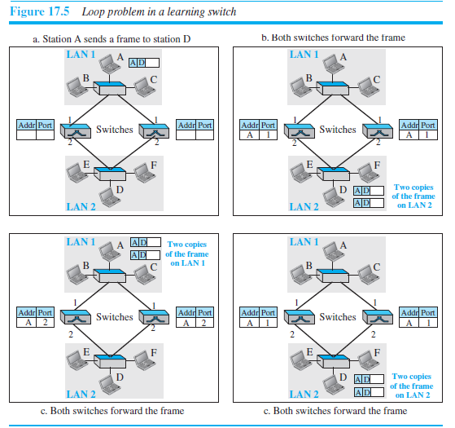

Although some textbooks represent the LANs as nodes and the switches as the

connecting arcs, we have shown both LANs and switches as nodes. The connecting

arcs show the connection of a LAN to a switch and vice versa. To find the spanning tree, we need to assign a cost (metric) to each arc. The interpretation of the cost is left up to the systems administrator. We have chosen the minimum hops. However, as we will see in Chapter 20, the hop count is normally 1 from a switch to the LAN and 0 in the reverse direction.

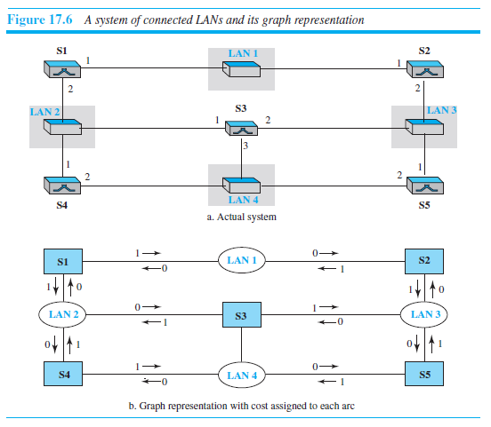

The process for finding the spanning tree involves three steps:

1. Every switch has a built-in ID (normally the serial number, which is unique). Each switch broadcasts this ID so that all switches know which one has the smallest ID. The switch with the smallest ID is selected as the root switch (root of the tree). We assume that switch S1 has the smallest ID. It is, therefore, selected as the root switch.

2. The algorithm tries to find the shortest path (a path with the shortest cost) from the root switch to every other switch or LAN. The shortest path can be found by examining the total cost from the root switch to the destination. Figure 17.7 shows the shortest paths.

3. The combination of the shortest paths creates the shortest tree, which is also shown in Figure 17.7.

4. Based on the spanning tree, we mark the ports that are part of it, the forwarding

ports, which forward a frame that the switch receives. We also mark those ports

that are not part of the spanning tree, the blocking ports, which block the frames

received by the switch. Figure 17.8 shows the logical systems of LANs with forwarding ports (solid lines) and blocking ports (broken lines).

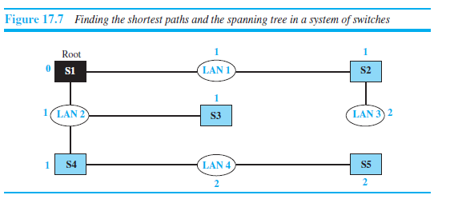

Note that there is only one path from any LAN to any other LAN in the spanning

tree system. This means there is only one path from one LAN to any other LAN. No loops are created. You can prove to yourself that there is only one path from LAN 1 to LAN 2, LAN 3, or LAN 4. Similarly, there is only one path from LAN 2 to LAN 1, LAN 3, and LAN 4. The same is true for LAN 3 and LAN 4. We have described the spanning tree algorithm as though it required manual entries. This is not true. Each switch is equipped with a software package that carries out this process dynamically.

----------------------------------------------------------------------------------------------------